Memo app design document
Modified: 4.12.2019
Version: 0.1

Description
User can log in and store notes. Stored notes are shareble with other users. App works with destop browsers (Chrome, Firefox) and with mobile phones (Android).
Notes are stored into database.

Logic
When logged in:
- list added notes
- add new note
- modify existing note
- undo modification of a note
- redo modification of a note
- delete existing note
- bring back deleted note (last 5)
- add another user as a friend
- share a note with friends
- log out

When logged out:
- show add note
- list added notes
- show login button
- show github link

Database

Version 0.1
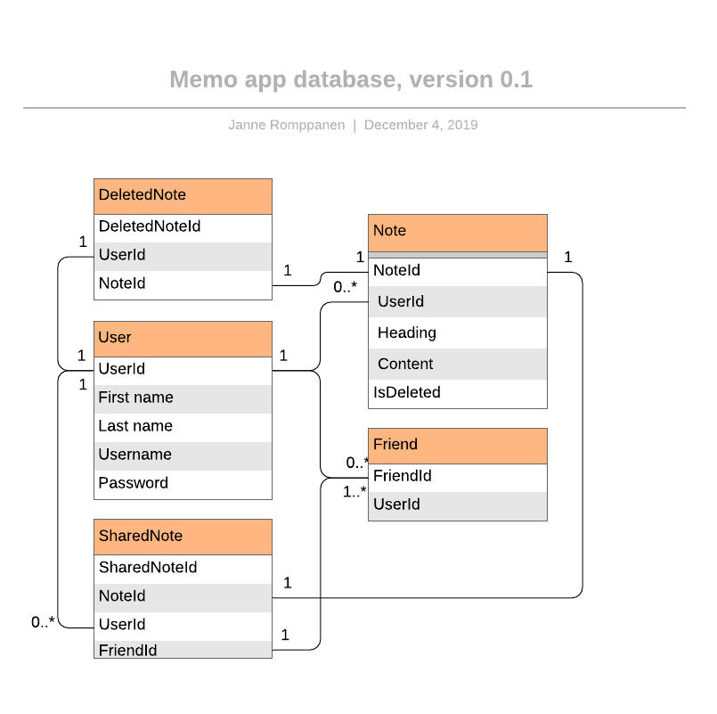

Technical design
Template: React
Backend: Node.js / Express.js
Database: MongoDB / Mongoose
Style: Bootstrap
Linting: Eslint / eslint-plugin-react
Testing: Jest
Compiling: Babel

